Functional requirement of grocery

# Manage orders

When you create a profile, you don't have to re-enter the details every time when shopping needs to be made.

Once a profile is set up, the name of the customer can be used to make orders. Details about the customer are filled automatically while placing the order. To place the order, the customer has to specify the mode of pay.

# Features Supported In Application Functions available are as follows:

* 1. Create profile
  2. View items
  3. Edit cart
  4. Select items to order
  5. Payments

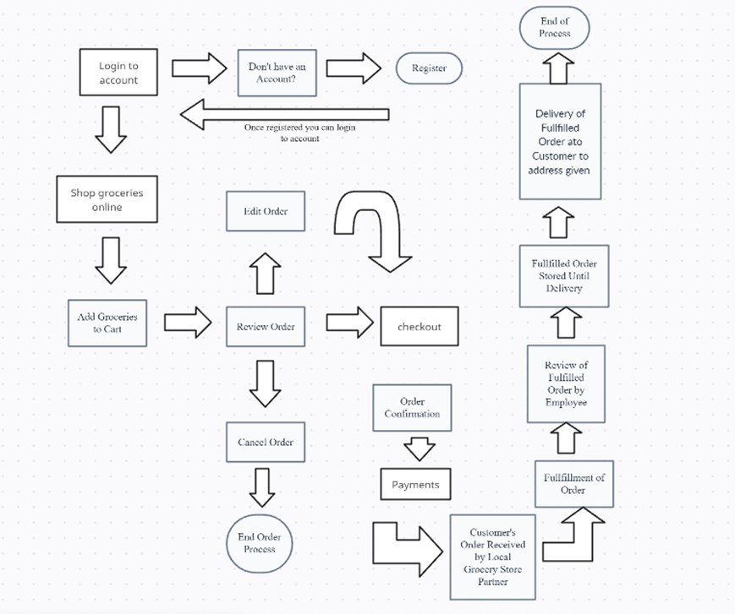 **Workflow**

**Fields in home page**

**Field Name Description**

|  |  |
| --- | --- |
| profile | Displays customer information. |
| Item List | Displays the list of item names. |

# Below fields appear if you click down against the cart

|  |  |
| --- | --- |
| Name | Name of the customer. |
| Item | Name of the item ordered. |
| Add New item | Link to add a new item. |
| Delete item | Link to delete item. |

Functional requirement: Sign up

* Description: User need to fill their details to create new account
* Input: name, email, mobile number, password, address
* Processing: It will create a new account for user if all information is correct.
* Output: Display the created account information.

Functional requirement: Login

* Description: User get access to their created account by login.
* Input: enter the username and password.
* Processing: Check if it is available or not.
* Output: open home page

Functional requirement: Categories

* + Description: Categories is the group of types of grocery, each collection further have subcategories of grocery.
  + Input: Go to the Categories buttons
  + Output: Display all the categories.

Functional requirement: Fruits and Vegetables

* Description: User can check fruits and vegetables
* Input: select fruits and vegetables
* Processing: Display shifts from the homepage to list of fruits and vegetables types items arranged according default sorting type.

Functional requirement: Offer Zone

* Description: User can view available offers.
* Input: Select offer zone
* Processing: Display shifts from the homepage to list of offers types arranged according default sorting type.

Functional requirement: Change Password

* Description: Change password
* Input: Enter the existing password and the new password
* Processing: Finishing authorization.
* Output: Password changed successfully

Functional requirement: Search grocery here

* Description: Customer can search grocery here
* Input: Enter keyword, item name
* Processing: Show suggestions if the keyword matches the popular or previously searched items also.
* Output: Show suggestions, highlights search options.

Functional requirement: Cart

* Description: This module allows user to make list of items, can buy later

Functional requirement: Delivery Details

* Description: Customer address where the order can be delivered
* Input: Enter the address with the pin code
* Processing: Display shifts from delivery details to payment method
* Output: Promote to payment method.

Functional requirement: Orders

* Description: Open the orders page
* Input: Select orders
* Processing: Display shifts from current page to order list and details.
* Output: Promoted to order list.

Functional requirement: Track Order

* Description: Customer can see the current status of their order
* Input: Select track order option.
* Processing: Display shifts from order status to order received from delivery man.

Functional requirement: User review

* Description: Submit your own reviews
* Input: Enter your reviews
* Processing: Submitting the review
* Output: Review submitted successfully